How To Receive My Anointing For Your Life Everyday
September 17, 2016
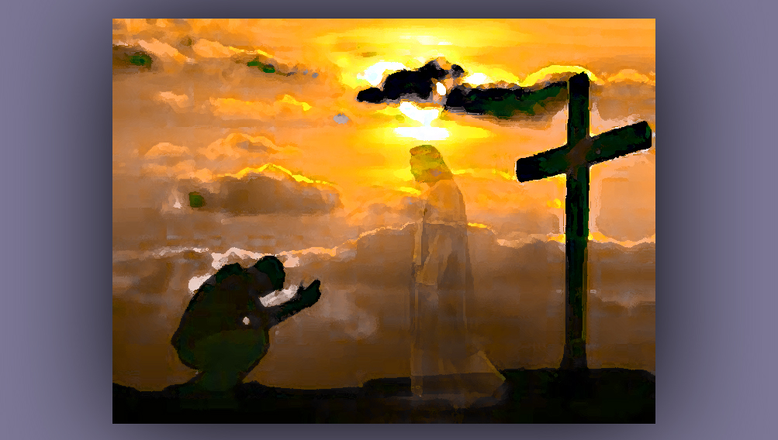
The sweet blessing of the Lord's presence in your life everyday, be with you, Heartdwellers.

Well, I started off with that blessing, because due to pressures from family, doing an interview with Ezekiel and other things that just kept piling up on me - I didn't get a chance to really listen to the Lord for the current message each day for the last 3 days. Wow, have I been feeling a vacuum in my heart! A real emptiness and an insecurity, kind of like...floating out there somewhere, not tethered to the Lord, which I normally feel very strongly.

So, this morning when I got up, I told the Lord, "This is my first priority - to be with You, Jesus."

I came into prayer immediately and asked that He would speak with me, 'cause I needed to be settled in my heart. And the first thing He said to me was, "Well, you wanted a little break."

Well, that was true. I had a bunch of things I needed to do. Not the least of which was family showing up. I just really felt the void of not speaking to Him every day.

It was awful.

So, I answered Him, "It was AWFUL, Lord!"

He answered me, "You had to find that out for yourself. Clare, you will never find your peace in anything or anyone but Me, even things ordered by Me.”

“I am the true vine, and my Father is the gardener. No branch can bear fruit by itself. It must remain in the Vine. Neither can you bear fruit unless you remain in Me. I am the Vine. You are the branches. If you remain in Me and I in you, you will bear much fruit. Apart from Me, you can do nothing.
John 15:1-5

Lord, do you want to use this as your topic for today?

"You know I make the best of every situation, why should this be any different? You see, My dear ones, there is a tendency to put off time with Me in order to get something else accomplished…more time for other things you’ve been wanting to do. And when you leave off with Me, you actually disconnect from the source of life.

"I am the life that brings forth fruit in your life. To think that you can run on the inspirations of yesterday - old manna - and still feel fulfilled is an illusion. Everyday I must fill you with fresh inspiration, because everyday you will face new trials and forks in the road. When the anointing resides as a living force in you, refreshed every day, then you meet these challenges and joy - in My Spirit, not in the flesh.
“The Earth has grown very old, indeed. Sin swathes it spiritually like a filthy vapor and just as barometric pressure affects physical life, so does spiritual filthiness bring pressure to bear upon your spirits. This is why so many of this new generation seem to be equipped more spiritually, they must be able to navigate the turbulent times of proliferating sin.

"You, My Beloveds, are under a tremendous cloud of uncleanness which causes not only your discernment and thinking-spirit-soul connection to be tattered and worn thin, but it affects your body and aging as well. Just as in My Being I have three parts: Father, Son and Holy Spirit - you, too, have three parts: spirit, soul and body. These must be in agreement, in alignment, in unity. The pressures of your spiritual atmosphere are so thick and contaminated, that these easily are displaced out of alignment with one another.

"In Heaven, there is no such lack of alignment or pressure. That is why My Children in Heaven are so brilliant and filled with fresh life. They are immersed in a holy atmosphere where no evil can approach or affect life there. Nothing comes under the influence of degenerative forces and all live forever in perfect health, both spiritually and physically, in resurrected bodies.

"If you grasp this concept deeply, you will come to understand how essential our time together is, and that you receive instruction from Me on a daily basis. If you feel that you do not hear Me clearly, use the Scriptures as your interface, until you feel more secure in our connection.

"I am not a far away God! I live right inside of you, where your conscience resides. I live and breathe and impart wisdom, knowledge and new life right there inside of you. Yes, you can travel to Heaven and experience My Heavenly Abode. But remember that all of Heaven and Creation reside within your heart as another dimension, because I live there and it is by My love that Heaven and all creation is held together. This is the reason that you may enter Heaven through your heart, by coming into the Throne room where I reside. As you come closer and closer to Me, and even enter into the dimension of My Heart where Heaven exists, the portal to Heaven is open to you.”

“In Him we live and move and have our being.” Acts 7:28

He continued, "Where I am taking you, My Beloved ones, is to drink from the source of living waters, everyday, without exception. Many of you are still confused about how I speak with you. Indeed, it is a still small voice coming from your hearts. Tuning is essential to reception, just as in a radio frequency.

"However, when you are not yet comfortable with that, you may enter into My wisdom and guidance through the Scriptures. I will indeed illuminate words of counsel and understanding as you read the Living Word. How, You ask? Reading between the lines. In other words, as you read you are recognizing words and putting their meanings together to form sentences. At the same time you are recognizing the meaning of those sentences at face value.

"Yet there is another dimension - reading the intent, the more subtle message - the between-the-lines meaning. In this process, you are applying what is written to your present time life and circumstance. And these are answers for you, directly from me.

"When I anoint something for you, when you pray for guidance from My Holy Spirit and begin to read, something will catch your attention as being especially relevant to your present situation."

I know for me, sometimes, when that happens I say, "Wow! This sounds exactly like what I'm going through right now. Bingo!" It is, and that's how He's answering me.

He continued, "You will feel it in your heart. That is a illuminated word for you to apply to current living situations. Once you begin to grasp that, you are coming closer to the tuning that is necessary to hear My Voice from your heart directly.

"When you sit and write or type a letter to Me, I listen and understand very clearly what you are saying. This is entering the foyer of My throne room. As you finish your sentences and expect Me to reply, even asking in faith, “Lord, what do you have to say about this?” I then reply, and you may begin typing as I speak.

"Don’t allow fear and scrutiny to get in the way. Just write what you feel I am saying to you. If you are bitter, in a state of anger or retaliation, and the words you write that you think I am saying - if they too are angry or retaliatory, you are hearing from yourself or a demon. But if the words bring peace and resolution…then, you are most likely hearing from Me.

"When you are done typing, go back and read what you wrote and apply the rules of discernment you have learned on this channel. I am never haughty or degrading towards anyone. I am always tender, meek and mild, unless I am having to give a serious exhortation to turn someone from sin. But even then, I am never haughty or degrading, but just adamant and firm, leaving a way out for those I am addressing.

"These are the living waters you MUST be nourished on everyday. Even if it is only a simple “‘I’m here.” Still, it will settle your soul and bring you peace.

"Some of My servants and Brides have offered Me the gift of hearing My voice daily for the edification of another who would not normally hear My voice - just to get them started and established in hearing from Me.

"But for you who are just starting out on this journey, I am here for you and I long to exchange words from My heart to you daily, if only you will take the time to tune in to Me and maintain it. After all, what more precious gift can you have than the love of My heart, accompanied by loving words and counsels.

"But let this brief time of not receiving fresh manna be a lesson to all, that you do not live by bread alone but by every word that comes forth from My mouth."

Then the two Scriptures that came to mind were:

"He humbled you and let you be hungry, and fed you with manna which you did not know, nor did your fathers know, that He might make you understand that man does not live by bread alone, but man lives by everything that proceeds out of the mouth of the LORD. Deuteronomy 8:3

"It is written: 'Man shall not live on bread alone.'" Luke 4:4

Jesus continued, "Seek Me daily, without fail, and you shall live the abundant life I have promised to all of those who love Me. A spiritual life, filled with wisdom and joy. Follow Me. Listen to Me daily and take My words to heart. Live in obedience to those words. And truly your life will bear much fruit.

"I love you, My sweet Bride. I am coming for you. Don't let that vision slip away. Tuck it away in your hearts and meditate on it frequently. You are indeed My Bride and My Love, and I will come for you. In the meantime, seek Me daily and lead your life in My anointing."

